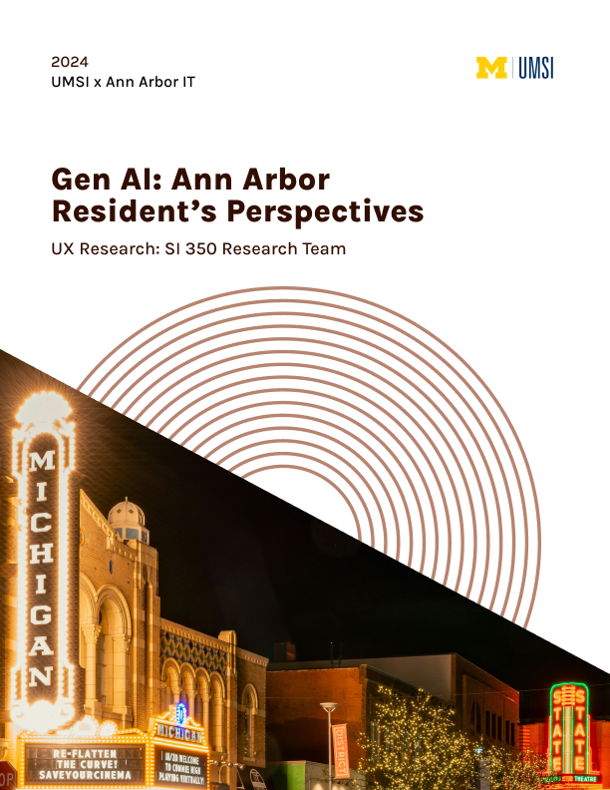

Table of Contents

Introduction ……………………………………………………………………………………….2

Methods of Collection ……………………………………………………………………………3

Insights and Recommendations ………………………………………………………………..6

Conclusion ………………………………………………………………………………………..14

Appendix ………………………………………………………………………………………….15

Introduction

Background
The City of Ann Arbor is committed to enhancing public access to information. Ann Arbor City Hall customer service currently receives a high volume of phone calls and emails that pertain to information that could be found on the city’s website. Therefore, the project aims to prioritize the efficient access of information to the public, particularly during high demand events. The project will give city hall employees the time to engage in other meaningful work which will be more intrinsically gratifying and beneficial to the entire city of Ann Arbor.

Objective Statement
The City of Ann Arbor is currently unaware of residents’ feelings about the clarity and availability of information on the city website, therefore it is important to collect data about their experiences. Additionally, it is essential for the City to know about the resident’s views and experiences with generative artificial intelligence (GenAI) to gain insight about reactions they will receive upon launch of the interface. The objective of the GenAI interface is to meld these two experiences into one by using the GenAI to ask questions about the City. Thus, the data will provide a clear understanding of the experience around the use of the GenAI interface to answer questions people have about the City of Ann Arbor.

Problem Statement
How might local government use GenAI to answer residents’ questions about the City of Ann Arbor?

Research Questions
Our team has developed the following research questions (listed below). These questions will shape our approach to research. They will be used throughout the entire process to ensure that the research conducted addresses the scope and objective of the project.

Research Questions (RQ)
RQ 1: What are attitudes toward local governments using GenAI to answer questions?
RQ 2: What are the current experiences of getting questions answered by the city?
- What obstacles/ motivations/goals do they have?
RQ 3: When people use GenAI to answer questions about local government, does it meet expectations?
- How are expectations and success measured?

Methods of Collection

Online Survey
Our final method of data collection was through an online survey. This method aimed to collect more surface-level insights on a person’s experience and sentiments regarding retrieving information about Ann Arbor through GenAI. It was conducted through Google Forms, where we collected 656 total anonymous responses from people around Ann Arbor. Residents from Ann Arbor made up 88.7% of the participant pool.

To maximize reach, participants were recruited through a variety of means. Each student in the class used varying methods to ensure responses best represented the wide range of people in Ann Arbor, from personal networks to strangers. Methods included online means such as the Nextdoor app, University of Michigan-affiliated Slack forums, affiliated Discord channels, and the r/AnnArbor Reddit community. Distribution was also done through in-person avenues with high foot traffic such as local schools, Ann Arbor-based small businesses, flyers passed out in Kerrytown’s Farmers Market, and posting QR codes throughout the Ann Arbor community. The largest sources of success were found through posting our survey link in active Ann Arbor Facebook group chats and on Nextdoor. This stratagem captured a diverse array of opinions, charting a broad spectrum of user information-seeking habits and preferences.

The survey’s inventory consisted of 6 questions that probed their experiences and attitudes concerning the process of asking questions and seeking information about the City of Ann Arbor through GenAI. The order followed a funnel formatting, where the survey starts by inquiring about general knowledge and familiarity with GenAI, to more specific questions about participant’s emotions and trust of GenAI being utilized in the local Ann Arbor government. This method ensured that questions did not instill bias in participants’ responses.

The first question asked if the participant was a resident of Ann Arbor. This helped isolate our target subjects of study. Next, we asked participants to select their methods of searching for information about the City, as well as what characteristics they valued the most when searching for information. We then asked participants to rank their comfortability and trust in using GenAI to answer questions about the city, and finally a free-response where they described their feelings about using GenAI. The survey ended with two logistical sections regarding whether participants wanted a follow-up interview, and the distribution tracking number of SI 350 students.

The limitation of the survey is that 58.1% of responses came from two social media platforms - Nextdoor, and Ann Arbor Community Facebook groups - which are designed for community announcements. This may have biased the sample because people who use specific social media platforms may have different interests, demographics, and opinions compared to those who do not. Therefore it may not reflect the broader population of Ann Arbor.

Community Diary Study
Our second data source was an internal diary study conducted within the scope of our student research team. The data our team collected from our internal diary study was a sample demonstration of experienced GenAI users using GenAI (UM-GPT) to answer questions about the City of Ann Arbor. The study recorded 121 responses (all 21 students in the SI 350 course). Each student responded approximately six times during the first two weeks of the course. Each form entry was based on the student’s reactions to a community-related question entered in UM-GPT. One of each six individual responses was based on a question that arose from participation or attendance in a public Ann Arbor government event/meeting.

The survey itself asked respondents to record their community-related questions and any follow-up questions they may have asked UM-GPT. It also asked respondents to include characteristics of the information returned from the question (detailed response, sources included, etc.) and whether or not the response was believed to be accurate. The form also asked whether the respondents believed the information came from the City and if they believed a city employee would have provided the same information. Finally, each respondent was asked for a two-sentence summary of the experience.

Moderated Field Studies
Using semi-structured moderated field studies, the class split into four teams to gather qualitative data on Ann Arbor residents' initial reactions to using UM-GPT for City inquiries. Direct interactions with the GenAI interface enabled both exploratory and specific questioning, revealing detailed feedback through verbal and non-verbal cues.

We conducted 70 moderated field studies with Ann Arbor residents located on campus, downtown, up north near the Huron river, and many other public spaces in the city. Participants were also recruited from survey respondents who indicated an interest in being interviewed, taking place over Zoom. These moderated field study sessions, taking place between May 13 and May 15, 2024, offered insights into first impressions, usability challenges, and general emotions related to GenAI.

Each team prepared a unique field study protocol for their moderated field study – of which have been linked in the appendix. While the tasks and questions of each field study were different, the general structure was the same. The study began with questions about participants' knowledge of GenAI and what local concerns they may have, preparing them for subsequent tasks. Participants then engaged with UM-GPT to ask general questions about Ann Arbor, ranging in complexity - some of which were hypothetical queries containing false information. Finally participants were asked to reflect on this experience and describe their satisfaction with the GenAI interface and its responses.

The field study did have limited and skewed sample size - most notably by the abundance of university students and female participants due to the class’ demographics. The field studies, while rich in data, also restrict the quantity of participants due to their time-intensive nature. These implications may impact the broader applicability of the findings.

Insights and Recommendations

1 - Residents need fun ways to engage with GenAI to build confidence
The first insight we found is that residents need fun ways to engage with GenAI to build confidence.
- Residents who have positive or neutral assumptions about GenAI prefer self-exploration of the tool.
- Preference towards conventional sources limits the willingness to rely on GenAI for critical information.
- In cases where UM-GPT provides a non-answer, participants start to expect it to give vague responses for future uses.
- Participants found conversing with UM-GPT to be entertaining, but were still skeptical and preferred familiar sources like Google or their personal network.

Below, highlighted in pink, are some of the data we found relevant to our insight:
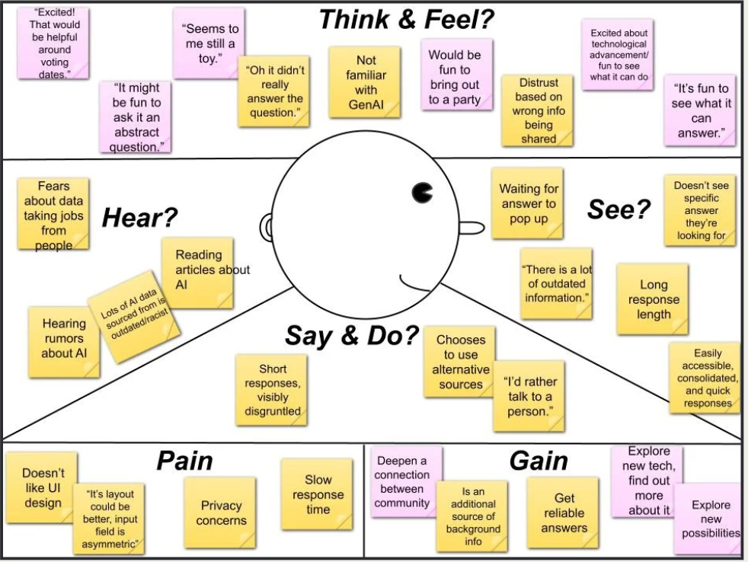
Figure 1. Empathy Map demonstrates that residents see potential for GenAI to be a fun experience.
We recommend that the City of Ann Arbor should collaborate with Ann Arbor organizations to promote using Citibot in a fun and engaging way.
- Create an in-person or website scavenger hunt about information relating to Ann Arbor
- Launch on social media to connect with the community
- Build credibility based on accurate and reliable answers

By doing so, this method lets people experiment with GenAI on their own. By letting them try GenAI in an exploratory and low-stakes setting where they’re not necessarily relying on it to provide critical information, it builds their confidence in both themselves and the tool. People could learn to trust it and connect more with the local government.

2 - Residents feel anxious about new technologies due to a lack of understanding
Our research highlighted that users with access to various resources felt uncertain and overwhelmed determining which source to use (Figure 2).

 | User: Middle-aged man, Ann Arbor resident, school faculty |  | Goal: Find information on Ann Arbor construction plans for 2024 summer
 | 1. Question | 2. Options | 3. Formulating Questions | 4. Processing the response | 5. Evaluation
Emotions | 🙁❓ | 👀💀 | 💡 | 🤓 | 😡
Pain points |  | Many options | Not knowing how to balance specificity of the question | Wordy responses | Is the information up-to-date and accurate?
Opportunities |  | Synthesizing information | Usage guidelines, examples, demo | Step-by-step guide  Visual aid  Bullet points
Insights |  | Different preferences in choosing the source of information, adding more options doesn’t solve the problem of anxiety
Figure 2. Journey Map highlights that residents feel anxiety when choosing between different resources to get their questions answered

From the Google form survey, our team learned individuals value three specific characteristics when they look for information about the City: clarity, specificity, and detailed answers (Figure 3). From our moderated field studies, we learned that users value tools they are familiar with and which fit their current needs. Many participants compared their experience with UM-GPT to experiences with Google and other information avenues, highlighting both positive and negative experiences in comparison. Participants both praised and critiqued the detailed answers provided by UM-GPT (some thought it was very detailed, others thought it was too long/not long enough). Other participants preferred the efficiency of accessing information provided by UM-GPT, while others felt the process was too slow. The high variance in opinion and experience with the technology played a large role in our shared insight.

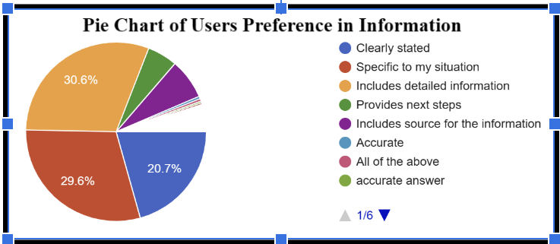
Figure 3. Responses to the survey question: Which of the following is the most important when getting your question answered about the City of Ann Arbor?

To improve residents’ experience using GenAI to seek answers to questions about their community, we suggest informing the residents that GenAI is synthesizing information from various channels and regularly updating data. Clearly stating that GenAI is drawing information from multiple channels on the tool can build reliability and encourage residents to consider GenAI as one of their options for finding information.

We also see an opportunity to increase awareness of GenAI and its capabilities by demonstrating how it provides answers to various types of questions accurately and quickly. Our research demonstrated familiarity is important to users when choosing an information source, especially when the user has feelings of uncertainty or anxiety. Because of this, our team suggests implementing and advertising opportunities for less experienced users to familiarize themselves with GenAI. Some examples of ways to do this are listed below.
- Educational Workshops: Host workshops at the library to showcase GenAI’s capabilities. These sessions can provide hands-on experience and demonstrate practical applications of the technology.
- Webinars and Community Events: Set up informational booths at city council meetings or community events to teach residents about GenAI. Virtual webinars can also reach a wider audience without incurring significant costs.
- University Partnerships: Collaborate with the Artificial Intelligence Lab at the University of Michigan to offer seminars and workshops. Leveraging academic partnerships can provide expert knowledge and credibility.
- Website Enhancements: Include a prompt on the GenAI website that explains where the information comes from, along with a dedicated web page offering detailed information about the tool. This will help increase user literacy, trust, and familiarity in GenAI.

By highlighting public demonstrations, tutorials, workshops, and other resources, the city can simultaneously demonstrate the efficiency/consistency in data provided by GenAI as well as build familiarity and trust with the technology.

3 - Residents are looking for GenAI responses to match what they are used to
Considering the data from all methodologies, it was revealed that the current methods of information retrieval that residents use conflict with the responses of GenAI, not matching what they are used to. As seen in Figure 4, participants predominantly utilize internet searches and the City of Ann Arbor Website to answer their questions about Ann Arbor. This essentially leads to comparison between a resident's own way of retrieving and retaining information, leading to dissatisfaction within the outcome versus expectations. Some affordances that participants look for in responses include links to webpages and resources, as well as concise and detailed answers to their specific questions.
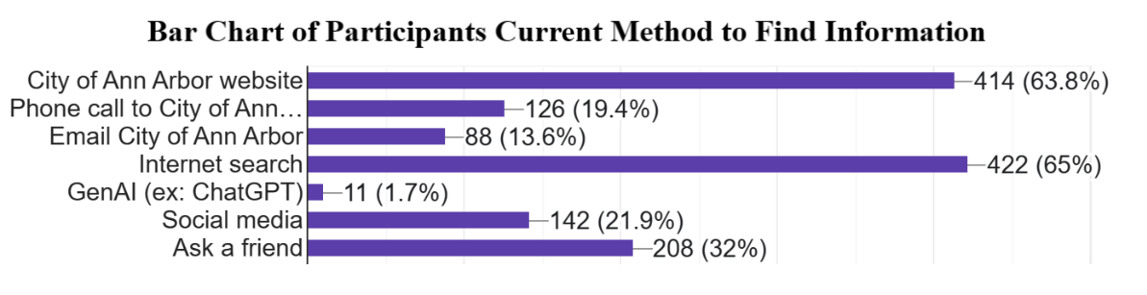
Figure 4. Responses to the survey question: When you have a question about the City of Ann Arbor, how do you get that question answered?

Participants have certain expectations about a good answer. We found a preference for specificity amongst survey respondents in that 29.6% of participants found answers that were specific to their situation are most important when getting their questions answered about the City of Ann Arbor (See Figure 3 above) One survey respondent noted that, “The stated answer is not specific and clear. And it takes a long time to generate the answer.” Another emphasized the need for tailored responses and stated, “I think it would be very helpful as long as it gave direct answers, specific to my situation, with sources listed.” Since participants are using the city website and an internet search the most currently, these methods must satisfy their need of receiving specific answers best.

During the moderated field study, the length of answers and lack of specificity were often pain points for participants. One participant said, “sometimes it takes a long time to read everything”. Reading through long answers and not receiving the information one needs caused a frustrating experience and led participants to feel overwhelmed. The participants reference their current information retrieval methods when comparing their experience with GenAI to doing a Google search. We created an empathy map (Figure 5) to understand different aspects of participants' experience, which shows their comparison to other tools in the Say and Do section. One participant said, “Just Google this” and another said, “ If I would have Googled it I would have gotten an answer immediately.” Their experience with GenAI is not mirroring their current methods to find information, which led them to compare the ways in which they get their questions answered.

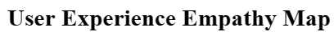
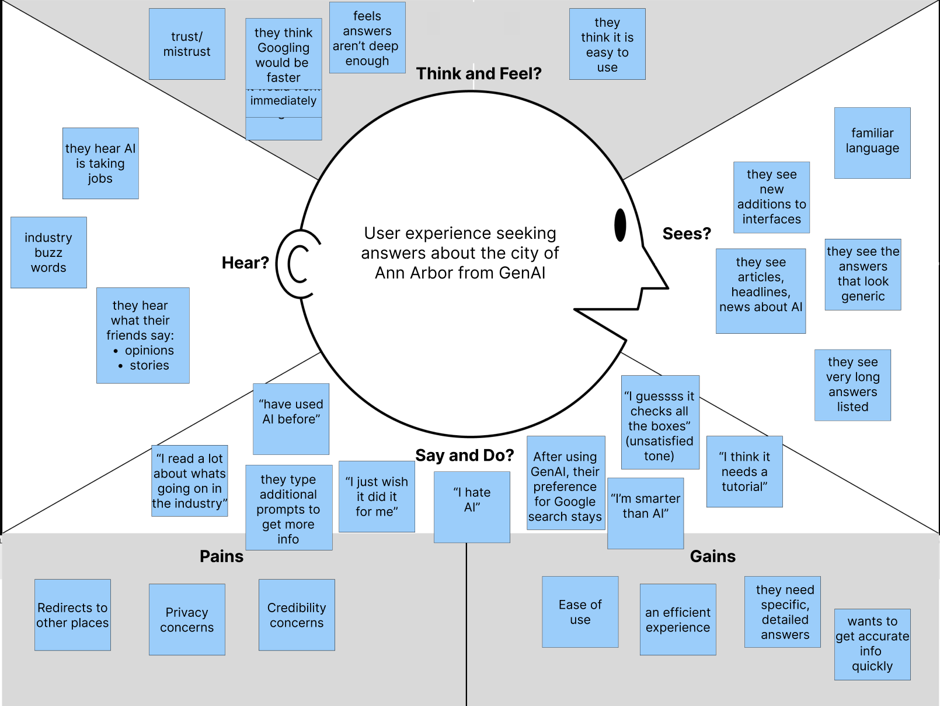
Figure 5. Empathy Map demonstrates that GenAI is not mirroring current search methods, which leads to resident dissatisfaction

The participants of the diary studies also commented on the generic answers they received from UM-GPT. One participant said that, “The response explained the generic details [/information] of the ordinance and gave more specifics when asked.” This quote shows that when there are additional prompts, it can help with specificity which previously wasn’t portrayed. Another participant said that “it just didnt recognize bloomfest was a real event despite me telling it that it was. It had generic things to do in Ann Arbor, and guided me to general websites but overall wasnt getting what I was getting at”. This participant expresses that they wanted specific things to do in Ann Arbor and not to be led to just general websites. They are dissatisfied as UM-GPT did not give them the response they expected that may have been similar to a different search method like the city website. Overall, through the lack of similarity to how they normally find information and the lack of specificity in GenAI’s answers, leaves participants unsatisfied by using GenAI.
We see an opportunity for the City of Ann Arbor to ensure that the GenAI responses suit the needs of the residents of Ann Arbor. The needs of the residents were outlined in the data results analysis. More specifically, residents felt mistrust within the response because of the language being used and are unsure of where the information is coming from; hence, responses should have citations in the form of links which reflect the mental models of internet searches. Because participants’s feel overwhelmed with the length of the answers received from the GenAI interface, it would be beneficial to make sure the GenAI interface includes information hierarchy allowing residents to skim through for most relevant information. This can be done through bolded words, bulleted lists, structured headings, etc. This, in turn, would shorten the time taken by the residents to absorb and process information because the structure is easy to follow. Additionally, there is another opportunity to introduce this tool alongside educational resources to help branch the learning curve that residents will experience while using this tool. This can be done through providing tutorials or other educational resources such as videos or articles.

4 - Residents feel more confident in the GenAI when sources are provided
After analyzing our data to consider and understand current Ann Arbor residents' experiences obtaining information and their attitudes toward GenAI, we found that there was a serious concern with the sourcing and usability of generated information.
From our survey, we asked residents to "Describe your feelings about using GenAI to answer questions about the City of Ann Arbor." We organized approximately 50% of the responses into categories as illustrated in Figure 6. Generally negative reactions included remarks like "Not comfortable with AI" and expressions of distaste such as "Yuck!" Conversely, generally positive reactions featured comments such as "I feel open-minded to using GenAI for asking questions" and straightforward acceptance such as "I feel fine about it."
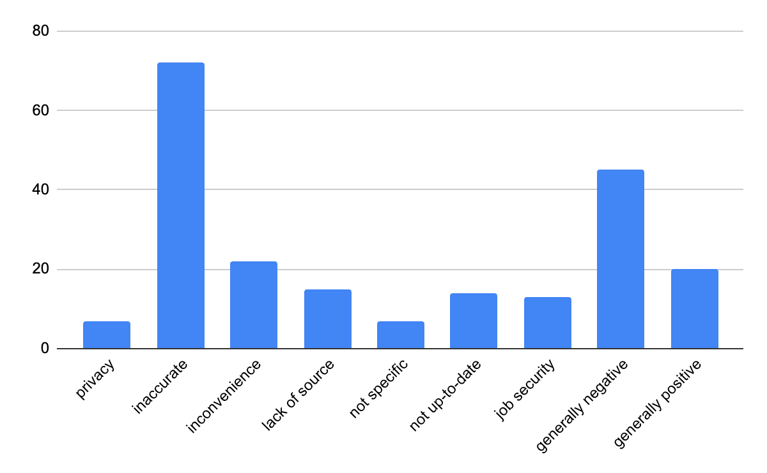
Figure 6. Responses to the survey question: Describe your feelings about using GenAI to answer questions about the City of Ann Arbor?
Thus, we recommend enhancing the transparency of information produced by GenAI by explicitly marking all disseminated information as originating exclusively from the City of Ann Arbor's website. To this end, GenAI could include explicit hyperlinks directing users to the exact locations on the city website from which it sourced its information. By making this clear, residents will understand they are accessing consistent information through the interface, regardless of whether they perform their search via the government’s website or contact the City directly. We believe that this level of transparency will significantly bolster residents' trust and confidence in the precision and dependability of data provided via the GenAI interface.
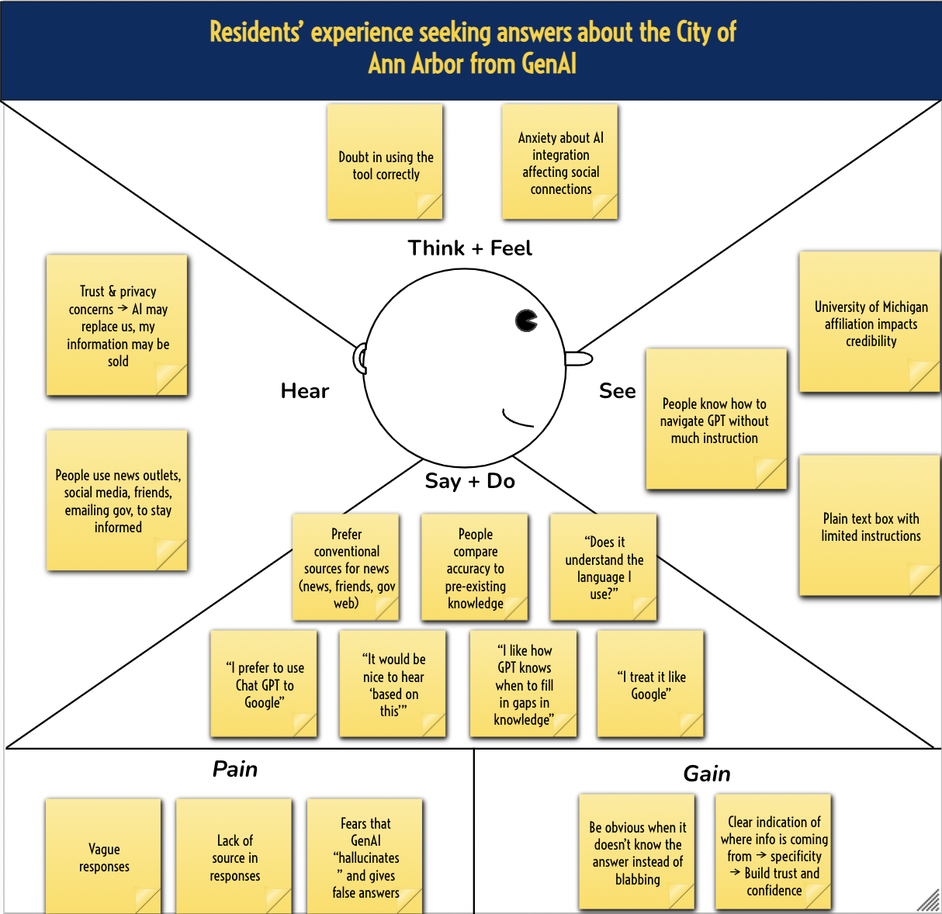
Figure 7. Empathy map highlighting resident quotes, including those related to sourcing
Analyzing the data collected from our survey and moderated field studies, we developed an empathy map (Figure 7) to gain a better understanding of how users felt about using GenAI interfaces to answer questions about the City of Ann Arbor. This empathy map acts as a visual tool to represent insights about the residents’ experiences and emotions, helping to capture what users say, think, feel, and do, as well as identifying pain points and opportunities for improvement.
During our moderated field studies, we observed that residents aren’t completely against generating responses but the lack of “according to…” or citations within the answer makes them hard to fully trust. One resident noted that “it would be nice to hear ‘based on this…’” as it would make the response feel more accurate. This sentiment highlights the importance of sourcing information in fostering trust.
“I feel comfortable with it as long as I could also call and get confirmation in person”
These outcomes suggest a prevailing concern over the usability and reliability of the information produced by the proposed GenAI interface.
Therefore, the City should provide supplementary material, thereby augmenting residents’ assurance when seeking answers to their queries. To enhance the user experience for all residents, including those unfamiliar with GenAI, we suggest the implementation of guidance on how to effectively utilize the GenAI interface. This guidance could be in the form of sample queries or through partnerships with local libraries to organize instructional sessions. The incorporation of these strategies will not only provide clearer answers but also foster an environment of greater reliance on the GenAI interface.

5 - Residents need prompting to enter follow-up questions to get higher answer satisfaction
The fifth and final insight we determined is that residents need prompting to enter follow-up questions to get higher answer satisfaction. Currently, 44% of experienced GenAI users (students from SI 350 who participated in the Diary Study) do not ask follow up questions, and 92% of residents (from the Moderated Field Study) do not know or use follow up questions in their interaction with GenAI. It is important to recognize that a lot of people do not know or do not use follow up questions to refine their question and deem the responses by GenAI inaccurate and/or unhelpful when GenAI potentially just needs some redirecting and refining of the question.
In terms of a recommendation that follows this insight, we suggest that the City of Ann Arbor implement something that prompts people to ask follow up questions for further clarifications and refined answers. By doing so, GenAI can increase confidence and satisfaction of users by answering the question in a more specific way

Conclusion

Key Takeaways
Our study reveals a significant interest and potential for enhancing public access to information in Ann Arbor to information in Ann Arbor, despite challenges related to trust and accuracy. Below is a summary of recommendations to consider moving forward:

- Creating tools to teach about and help familiarize residents with GenAI
- Providing clear citations for transparency
- Communicating the source of information is coming from the City website
- Formatting response information in familiar ways, such as bolding keywords, adding citations in the form of links, and reflecting mental models of internet searches
- Prompt residents to ask follow up questions for further clarifications and refined answers

Use of GenAI Statement
This report was edited with the assistance of GenAI. We also utilized GenAI to help analyze the survey data and identify key themes.

Appendix

List of Sources
Moderated Field Study Protocol Across Teams Complied
Survey Questions
Diary Study Questions
UM-GPT

List of Authors
The following is a list of students who contributed to this report for the course, SI 350: UX Field Research in the Public Sector:

Dahika Ahmed
Syeda Akther
Antonio Benedetto
Isabella Benjey
Robert Bowser
Andrea Gonzalvo
Sana Hashmi
Abhinand Keshamouni
Shantaisa King
Shannon Lee
Justin Mason
Stephen Milman
Olivia Pinto
Fahmida Rahman
Sadia Rahman
Maya Rai
Pearl Steenstra
Faye Stover
Ayat Tolba
Anita Tsai
Michaela Wu
Sifan Xue

